Project Synopsis — EdgeVoice: Real-Time MFCC Accelerator for On-Device Speech

HCLTech Career Shaper Programme | III Year Industry Project | 2026-27
Project Title | EdgeVoice : Real-Time MFCC Accelerator for On-Device Speech
Project No. | 186
Domain | VLSI / RTL Design
Difficulty | Medium
Duration | 4 Weeks
Format | Individual Project
Learner Name | Aditya Kumar Pal
Roll Number | 2400320310010
College / Campus | ABES Engineering College, Ghaziabad
Mentor Name | Mr. Kamal Bhatia
Submission Date | 31/10/2026

1. Problem Statement
Modern voice-enabled devices rely on Mel-Frequency Cepstral Coefficients (MFCCs) as the primary input to speech recognition and wake-word detection models. Software-based MFCC extraction is computationally expensive and power-hungry, which makes it unsuitable for always-on edge devices that must listen continuously on a tight power budget.
To address this, the project designs and implements EdgeVoice, a fixed-point VLSI hardware accelerator that performs real-time MFCC extraction for low-power, always-on speech AI systems such as wake-word detection and edge voice assistants. Fixed-point arithmetic is used throughout to minimise silicon area and power, closely reflecting industry practice in edge AI SoCs.

2. Proposed Solution & Approach
EdgeVoice is a dedicated MFCC hardware accelerator that processes streaming audio samples and outputs MFCC feature vectors. The base design uses simple frame-based control: it stores one audio frame, applies a Hamming window, passes the result through a provided or external FFT block, computes the Mel filter-bank output, applies log compression and performs a DCT to produce the final MFCC coefficients. Correctness of each DSP stage is the first priority; streaming and aggressive pipelining are optional extensions.
Solution Highlights & Implementation Approach:
- Frame-Based Datapath: Processes one fixed frame of 256 non-overlapping samples at a time, with a simple start/done interface and arithmetic hardware reused across cycles to keep the design small and easy to verify.
- Modular MFCC Pipeline: Separate RTL blocks for audio frame buffering, Hamming windowing, FFT interface, magnitude-squared, Mel filter bank, log compression, DCT and MFCC output buffering.
- ROM-Based Constants: Hamming window, Mel filter weights, DCT coefficients and the log lookup table are generated beforehand in Python/MATLAB and stored as constants/ROM, so no coefficient computation is needed in hardware.
- Fixed-Point Arithmetic: 16-bit samples and coefficients with wider (32-bit or larger) intermediate values wherever multiplication and accumulation require it. The scaling applied at each stage is documented.
- FFT Integration: A 256-point FFT is provided by an open/provided RTL block or treated as an external module; designing the FFT from scratch is not mandatory.
- Control FSM: A central finite state machine manages start/done signalling, frame control, ROM addressing and handshaking between stages.
- Verification: A self-checking testbench applies known audio frames and compares the 13 RTL MFCC outputs against a Python/MATLAB golden model built with the same fixed-point constants, within a small numerical tolerance.

Deliverables
- Synthesizable MFCC accelerator RTL with modular blocks for each MFCC stage
- Self-checking testbench with speech test vectors
- Functional simulation waveforms
- Synthesis reports (area, power, timing)
- STA reports with critical-path analysis
- Design document explaining the architecture and fixed-point decisions

3. System Architecture
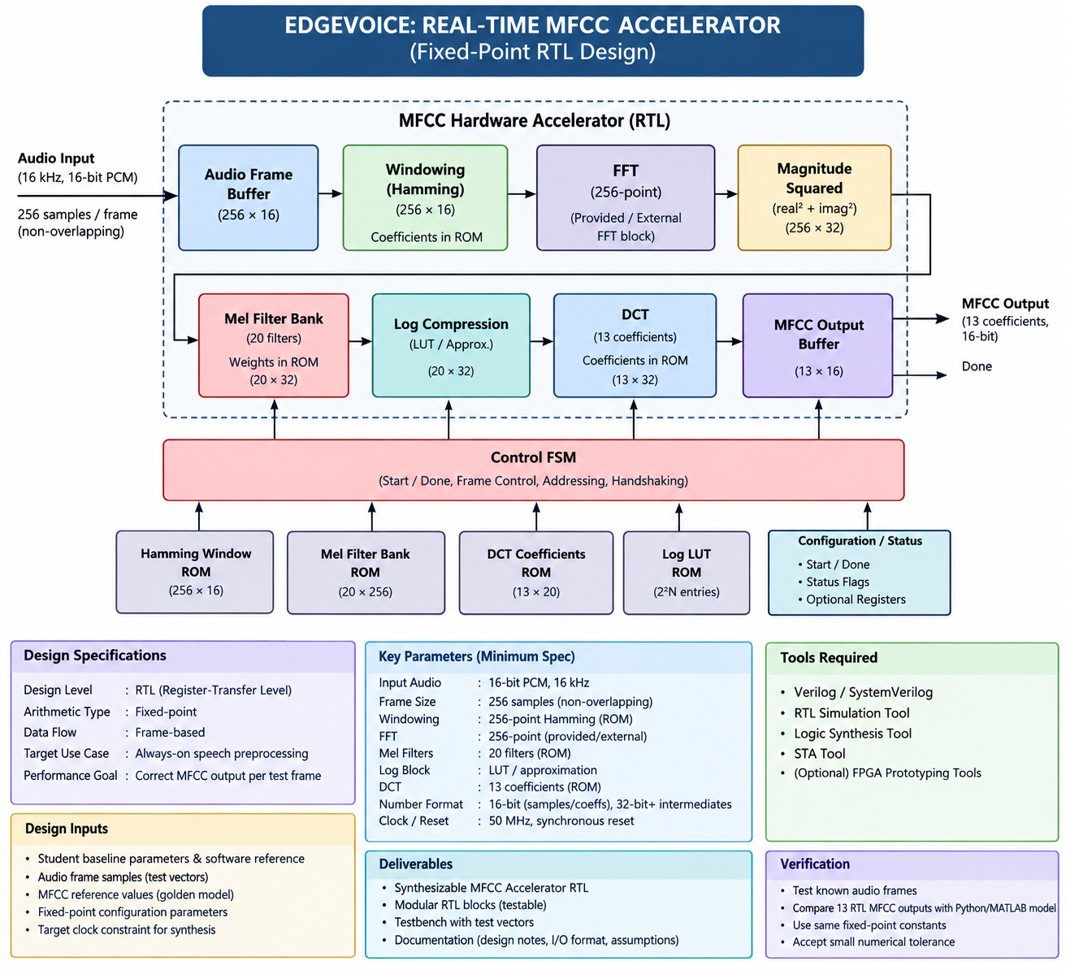
Figure 1: EdgeVoice top-level block diagram (fixed-point RTL design)

Data Flow
Audio enters as 16 kHz, 16-bit PCM in non-overlapping frames of 256 samples. Each frame is stored in the audio frame buffer, multiplied by the Hamming window held in ROM, and passed to the 256-point FFT. The magnitude-squared stage computes real² + imag² for each bin, and the Mel filter bank reduces the spectrum to 20 filter outputs using weights stored in ROM. Log compression (LUT or approximation) is applied to the 20 values, and a DCT using pre-calculated coefficients yields 13 MFCCs, which are held in the output buffer and signalled by a done flag. The Control FSM sequences all stages and ROM accesses.

Block-Level Description
Block | Function | Size / Format
Audio Frame Buffer | Stores one frame of incoming audio samples | 256 × 16-bit
Windowing (Hamming) | Multiplies samples by Hamming coefficients from ROM | 256 × 16-bit
FFT | 256-point FFT; provided/open RTL block or external module | 256-point
Magnitude Squared | Computes real² + imag² for each FFT bin | 256 × 32-bit
Mel Filter Bank | Applies 20 fixed Mel filters with weights stored in ROM | 20 × 32-bit
Log Compression | LUT or simple approximation of the logarithm | 20 × 32-bit
DCT | Produces 13 coefficients from 20 log-Mel values using ROM constants | 13 × 32-bit
MFCC Output Buffer | Holds final MFCC vector and drives the done flag | 13 × 16-bit
Control FSM | Start/done, frame control, addressing and handshaking | Synchronous FSM
ROMs | Hamming window, Mel filter bank, DCT coefficients, log LUT | 256×16, 20×256, 13×20, 2^N entries

Minimum Design Specifications
Design Parameter | Specification
Input audio | Signed 16-bit mono PCM samples at a fixed 16 kHz sample rate for all test vectors
Frame size | One fixed frame of 256 samples at a time; non-overlapping frames (overlap may be added later)
Windowing | 256-point Hamming window with pre-calculated coefficients stored in ROM
FFT | 256-point FFT; provided/open RTL block or external module
Spectrum | Magnitude-squared per FFT bin using real² + imag² (simple fixed-point implementation)
Mel filter bank | 20 fixed Mel filters; weights generated in Python/MATLAB and stored as ROM constants
Log block | Small lookup table or simple approximation; exact log hardware not required
DCT / output | 13 MFCC coefficients from 20 log-Mel values; DCT coefficients are pre-calculated constants
Number format | Fixed-point: 16-bit samples/coefficients, 32-bit or wider intermediates; scaling documented
Clock / reset | Single clock (e.g. 50 MHz) with simple synchronous reset; no multi-clock design
Verification | Several known audio frames; 13 RTL outputs compared with a Python/MATLAB model using the same fixed-point constants within a small tolerance

Top-Level Interface
Signal | Direction | Width | Description
clk | Input | 1 | System clock (50 MHz target)
resetn | Input | 1 | Active-low reset
start | Input | 1 | Starts processing of an audio frame
sample_valid | Input | 1 | Qualifies the incoming audio sample
sample_in[15:0] | Input | 16 | Signed 16-bit PCM audio sample
ready | Output | 1 | Accelerator is ready to accept a new frame
busy | Output | 1 | Frame processing in progress
done | Output | 1 | MFCC computation complete; results available
mfcc_addr[3:0] | Output | 4 | Index of the MFCC coefficient presented on mfcc_out
mfcc_out[15:0] | Output | 16 | 16-bit MFCC coefficient (13 coefficients per frame)

Sub-Module Hierarchy
Instance / Unit | Function
inst_fb | Audio frame buffer: stores the 256 incoming samples
inst_hw | Hamming windowing using coefficients held in ROM
inst_fft | 256-point FFT stage
inst_mag | Magnitude-squared computation (real² + imag²)
inst_mel | 20-filter Mel filter bank with ROM weights
inst_log | Log compression (LUT / approximation)
inst_dct | DCT producing 13 MFCC coefficients
Control FSM | State register (current_state[2:0] / next_state) sequencing the stages and generating ready, busy and done
MFCC output logic | mfcc_addr counter and output multiplexer that present each 16-bit coefficient on mfcc_out

Vivado RTL Schematic
The elaborated RTL schematic below shows the top-level module: the seven processing instances are chained from the sample input to the DCT, and the control FSM drives the ready, busy and done flags and the MFCC read-out path.
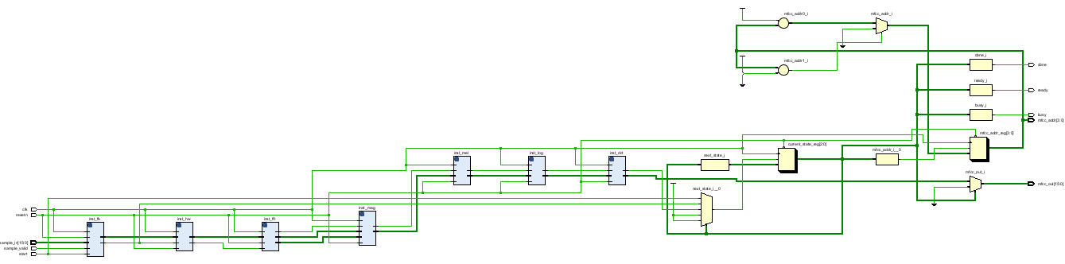
Figure 2: Vivado RTL schematic of the EdgeVoice top level

4. Technology Stack
Technology Layer / Category | Details & Tools Used
Hardware Description | Verilog / SystemVerilog (synthesizable RTL, modular blocks per MFCC stage)
Design & EDA Flow | AMD/Xilinx Vivado: project setup, RTL elaboration, synthesis, implementation and analysis
Simulation & Verification | Vivado Simulator with RTL testbench tb_edgevoice_mfcc.v and waveform-based functional verification
Arithmetic | Fixed-point representation; wider intermediate accumulators for energy and filter-bank calculations
Coefficient Storage | ROM/LUT structures for Hamming window, Mel filter weights, DCT coefficients and log approximation
Golden Model | Python / MATLAB reference model and generated test vectors for comparing MFCC outputs
Target Hardware | FPGA-oriented RTL prototyping and synthesis at a 50 MHz target clock

5. Dataset Used
EdgeVoice is verified with audio test frames rather than a large training dataset. The data used by the design is summarised below: the input audio format, the test vectors applied by the testbench, the pre-computed ROM/LUT constants, and the reference values used to check the 13 MFCC outputs.
Data Category | Details
Input audio data | Signed 16-bit mono PCM samples at a fixed 16 kHz sample rate
Frame format | 256 samples per frame, non-overlapping; one frame is processed at a time
Test vectors | Audio sample frames applied on sample_in[15:0] with sample_valid by the testbench tb_edgevoice_mfcc.v in the Vivado Simulator
Hamming window data | 256 pre-calculated coefficients × 16-bit stored in ROM
Mel filter-bank data | 20 filters × 256 weights, generated in Python/MATLAB and stored in ROM
DCT coefficient data | 13 × 20 pre-calculated constants stored in ROM
Log compression data | Lookup table (2^N entries) / fixed-point approximation of the logarithm
Reference (golden) data | MFCC values from a Python/MATLAB model using the same fixed-point constants; the 13 RTL outputs are compared against them within a small numerical tolerance
Output data | 13 MFCC coefficients × 16-bit = 208 bits per frame

6. Key Results & Metrics
Parameter | Value
Input audio | 16-bit PCM, 16 kHz
Frame size | 256 samples, non-overlapping
Window | 256-point Hamming
FFT | 256-point
Mel filters | 20
Log block | LUT / fixed-point approximation
MFCC output | 13 coefficients × 16-bit = 208 bits
Intermediate arithmetic | Wider fixed-point values/accumulators as required
Clock / reset | 50 MHz target clock, synchronous reset

Functional Simulation Waveform

Figure 3 shows the Vivado simulation of tb_edgevoice_mfcc over about 128.89 µs. It captures the top-level interface signals: the clock, active-low reset, start, sample_valid and sample_in[15:0] inputs, and the ready, busy, done, mfcc_addr[3:0] and mfcc_out[15:0] outputs. After the initial sample_valid pulse at start-up, the design sits in its idle state with ready high and busy and done low, and mfcc_out reads 0000

.
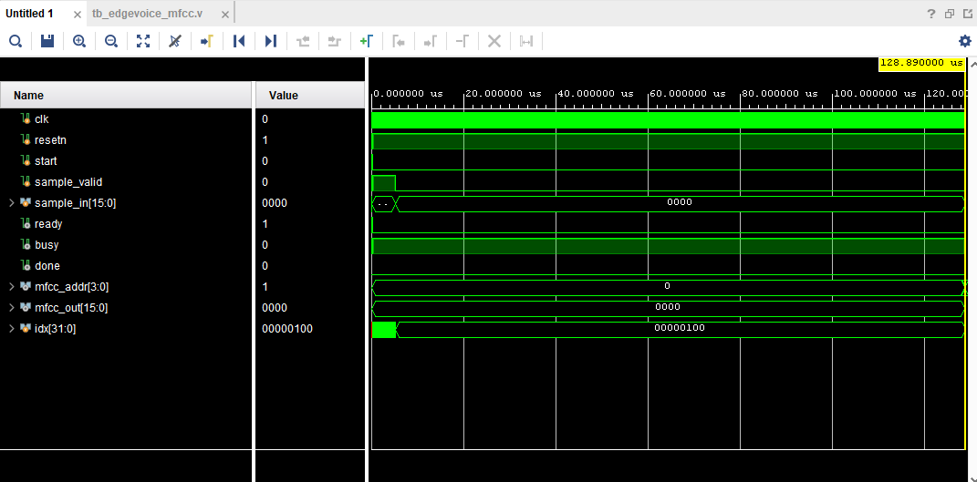
Figure 3: Vivado simulation waveform of tb_edgevoice_mfcc

Vivado Device View
Figure 4 shows the Vivado device view of the target FPGA with the design’s cells placed in the X0Y0 clock region, consistent with the small footprint expected of a frame-based, resource-sharing accelerator.
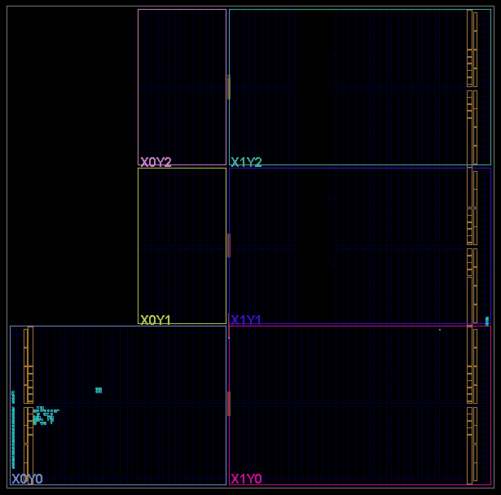
Figure 4: Vivado device view showing placement of the EdgeVoice design

7. Design Challenges & Resolution Approach
Challenge 1: Fixed-Point Precision and Scaling Across Stages
Resolution: Use 16-bit samples/coefficients with 32-bit or wider intermediates for multiply-accumulate operations, document the scaling applied at each stage, and validate against a golden model built with the same fixed-point constants.
Challenge 2: Integrating the 256-Point FFT with Frame-Based Control
Resolution: Treat the FFT as a provided/external block with a clearly defined interface, and let the Control FSM handle start, done and data handshaking so the rest of the pipeline remains independent of the FFT implementation.
Challenge 3: Log Compression Without Exact Log Hardware
Resolution: Implement the logarithm with a small lookup table or simple approximation (2^N entries) and accept a small numerical tolerance during verification.
Challenge 4: Keeping Area and Power Low for Always-On Operation
Resolution: Reuse arithmetic hardware across cycles, store all window/Mel/DCT/log constants in ROM, use a single synchronous clock and keep the base design frame-based rather than deeply pipelined.
Challenge 5: Synchronising the Processing Stages
Resolution: A top-level FSM with start, ready, busy and done signalling sequences the seven processing instances, from the frame buffer to the DCT, and controls the addressed read-out of the 13 MFCC outputs.

8. References
1. S. Davis and P. Mermelstein, "Comparison of Parametric Representations for Monosyllabic Word Recognition in Continuously Spoken Sentences", IEEE Transactions on Acoustics, Speech, and Signal Processing, 1980.
2. A. V. Oppenheim and R. W. Schafer, "Discrete-Time Signal Processing", Pearson.
3. L. R. Rabiner and R. W. Schafer, "Theory and Applications of Digital Speech Processing", Pearson.
4. HCLTech Career Shaper Programme, Project Brief: "EdgeVoice: Real-Time MFCC Accelerator for On-Device Speech", Academic Year 2026-27.

9. Ethical Compliance Declaration
I confirm that:
☒ All source code, test vectors and third-party IP (including any FFT block) used comply with open-source and institutional licensing.
☒ No personally identifiable information (PII) is stored or processed; test audio contains no private speaker data.
☒ AI tools used for structural formatting and documentation assistance are disclosed in the project submission.
☒ This project complies with applicable digital data protection standards (DPDP Act 2023).

Appendix A: Waveforms & Reports

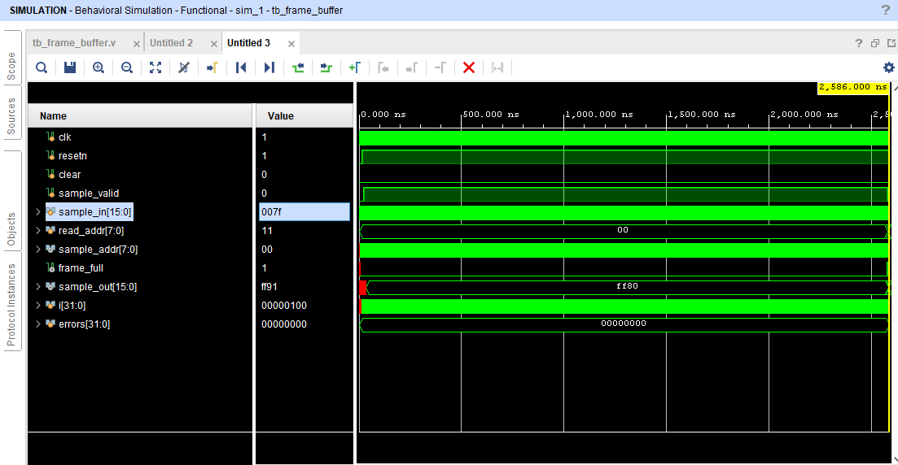

Framing_Buffer

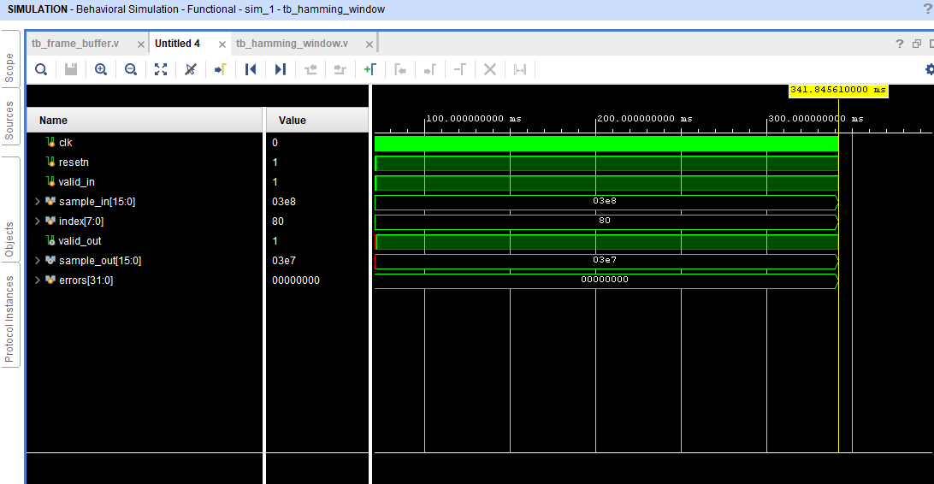

Hamming_Window

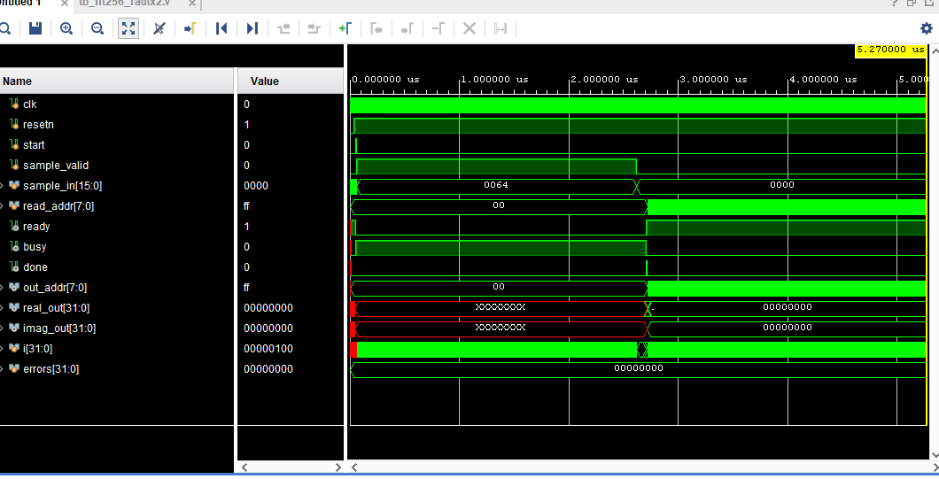

FFT_256

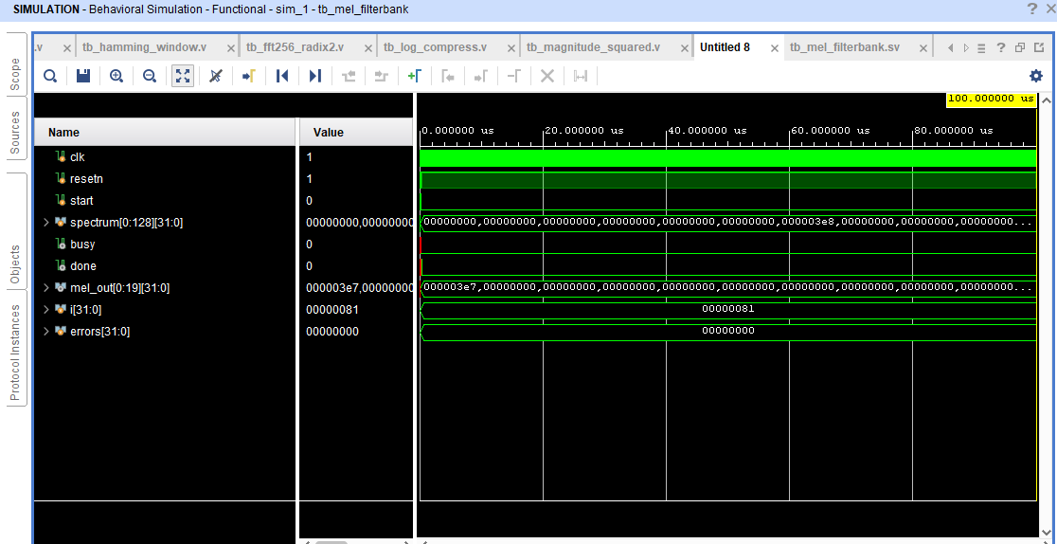

Magnitude_Squared

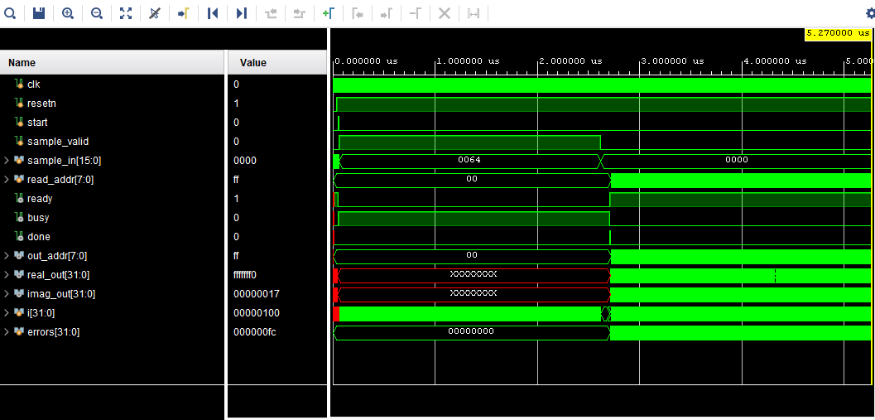

Mal_log_filters

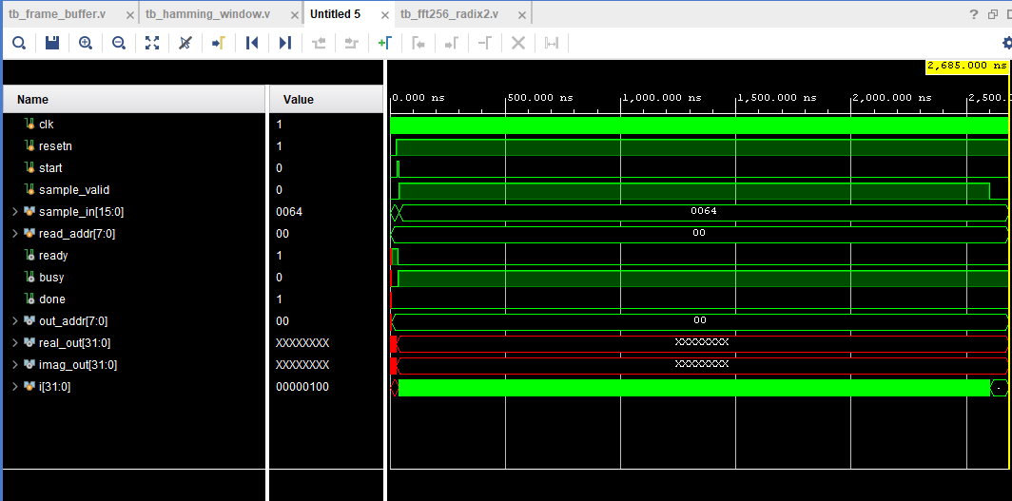

DTC

Learner Signature: Aditya kumar pal
Date: 31/10/2026

